- The hefty drop in CPI inflation in January largely reflected the impact of strong base effects and movements in volatile categories. We expect inflation to fall sharply in April, due to smaller regulatory price rises than last year, a lower energy price cap, and the impact of measures announced in the 2025 Budget. However, inflation is likely to drift higher again from H2.
- Incorporating new 2026 regulatory price announcements made over the past month and the annual update of the weights for the inflation basket means we now forecast CPI inflation to be slightly higher in 2026 and 2027.
CPI inflation cooled to 3% in January, from 3.4% in December. The chunky drop was primarily the result of powerful base effects and movements in some of the more erratic sub-categories. The base effects came from a strong reading for food prices and the introduction of VAT on private school fees in January 2025. Petrol prices fell sharply between December and January, after rising a year earlier. There was also some payback in the volatile air fares and games and hobbies sub-categories, as December's unseasonally strong outturns unwound. Elsewhere, RPI and RPIX also fell by 0.4ppts in January, to 3.8% and 3.7% respectively.
Looking ahead, several factors should pull headline inflation materially lower in the near term. We expect a combination of smaller once-a-year rises in index-linked and regulated prices, a substantial fall in the energy price cap, and the impact of policy measures from the 2025 Budget to drag inflation close to 2% in April. However, we think there's a good chance that inflation edges higher again from H2 2026, with sticky pay growth likely to prevent services inflation from cooling significantly.
The path for inflation this year is likely to be a little stronger than we previously forecast. This is partly due to us factoring in new regulatory price announcements over the past month, some of which have been slightly higher than anticipated. Meanwhile, the Office for National Statistics increased the weight assigned to services prices, which boosts headline inflation. Incorporating these changes into our forecast means we now see CPI inflation averaging 2.6% this year and next, up from 2.3% and 2.5% previously.
Chart 1: Regulatory price and weight changes have pushed up our inflation forecast this year and next
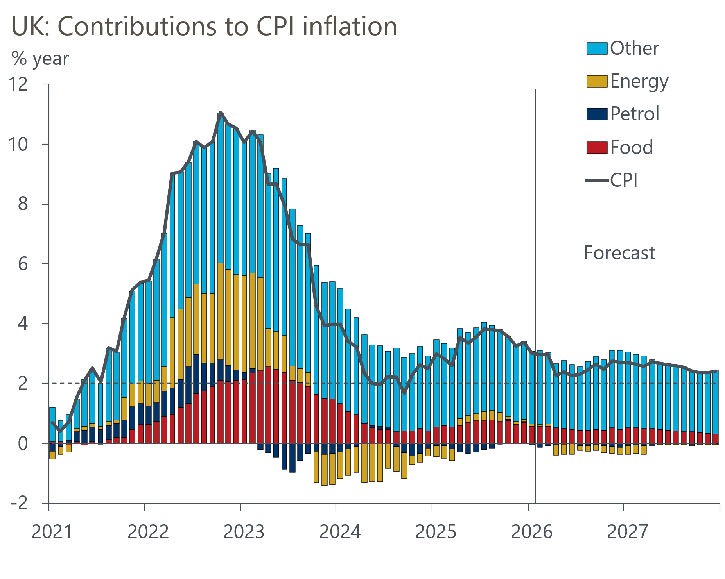
Source: Oxford Economics, Haver Analytics

